Threat Hunting with Open-Source Tools – Report

1. Objective
The objective of this exercise was to perform threat hunting using open-source security tools by ingesting logs, detecting suspicious PowerShell activity using Sigma rules, analyzing Event ID 4688, and documenting findings.

2. Tools Used
Elastic Security – Log ingestion and analysis
Security Onion – Monitoring platform
Sigma Rules – Detection rule creation

3. Methodology

3.1 Log Ingestion
Windows process creation logs (Event ID 4688) were ingested into Elastic Security.

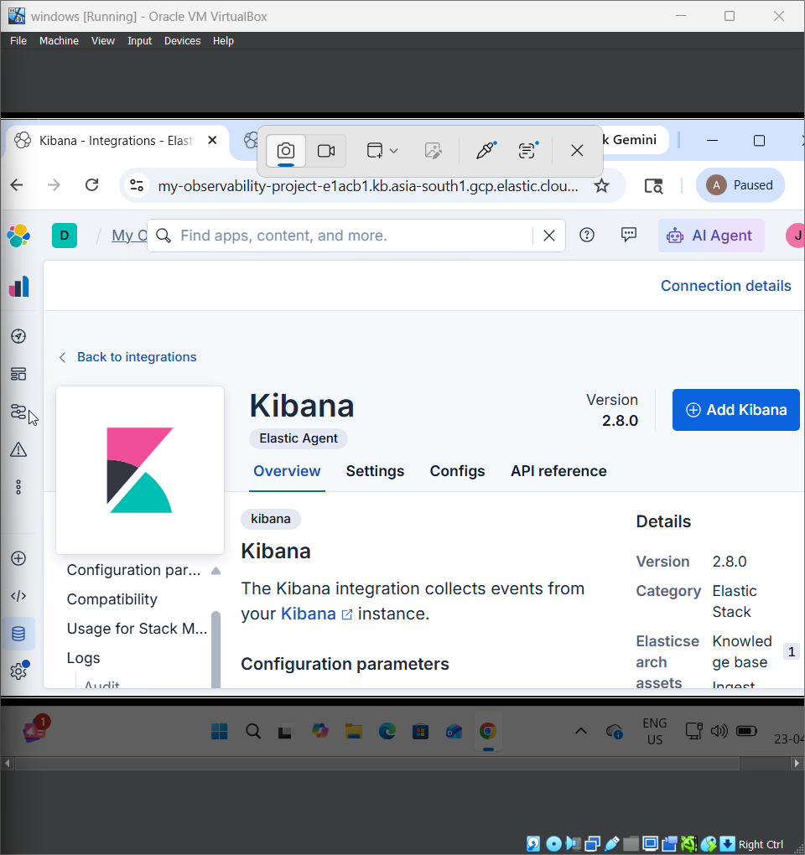

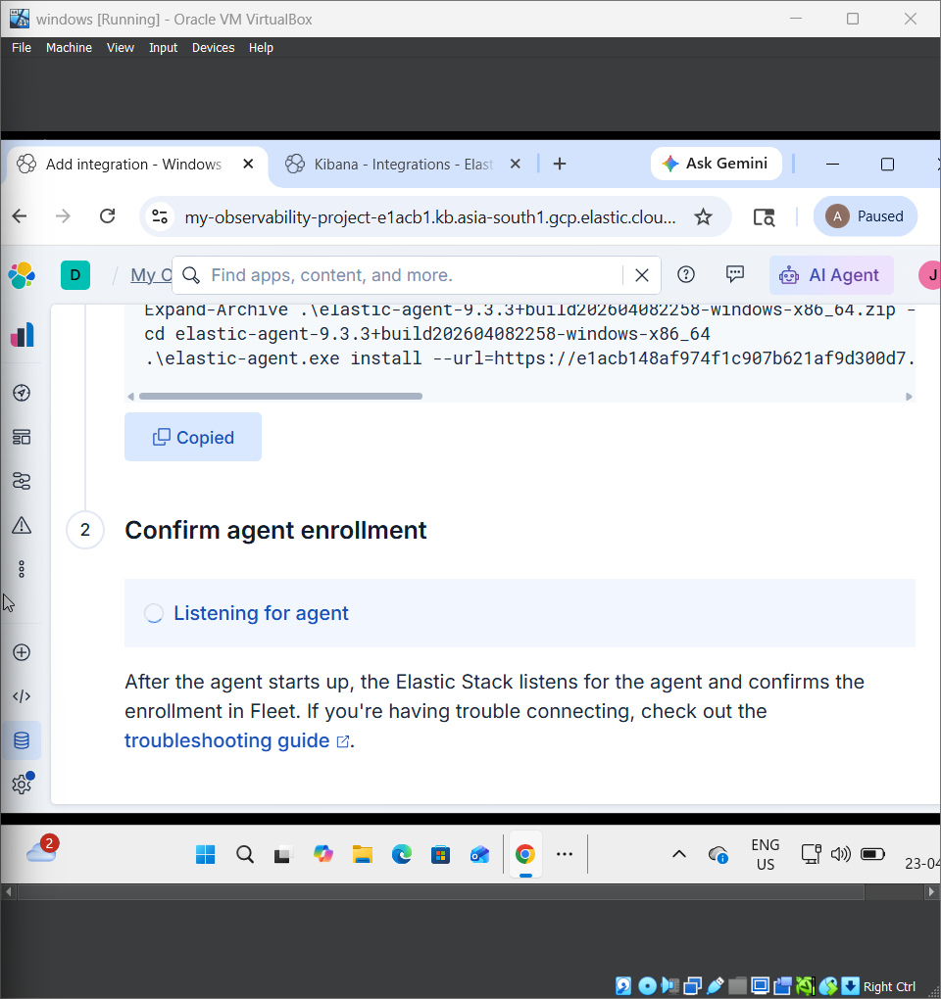

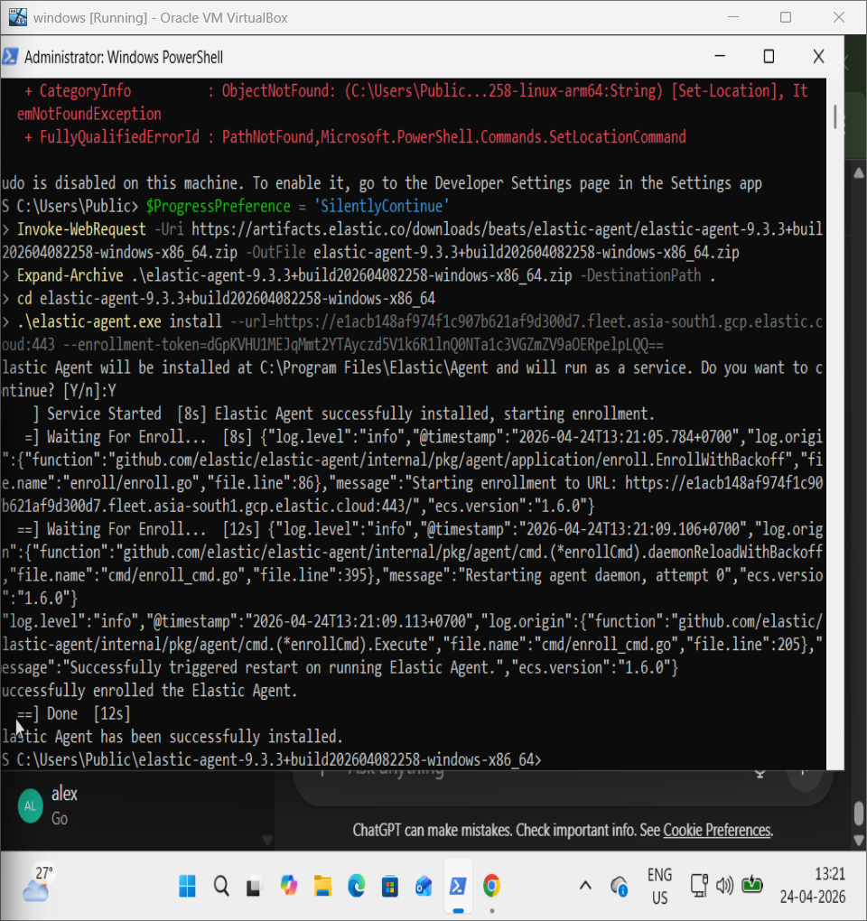

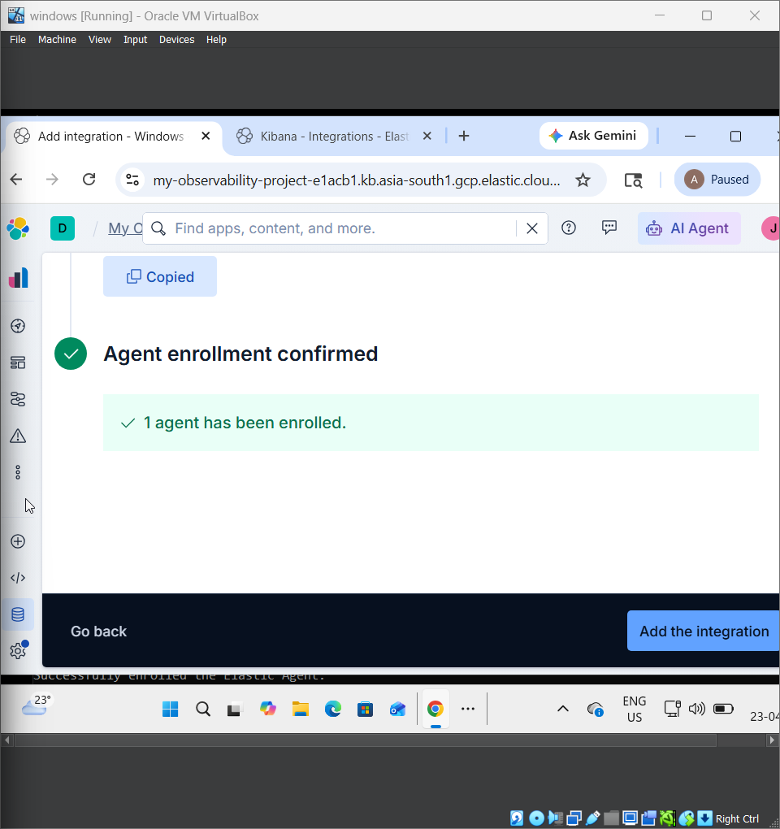

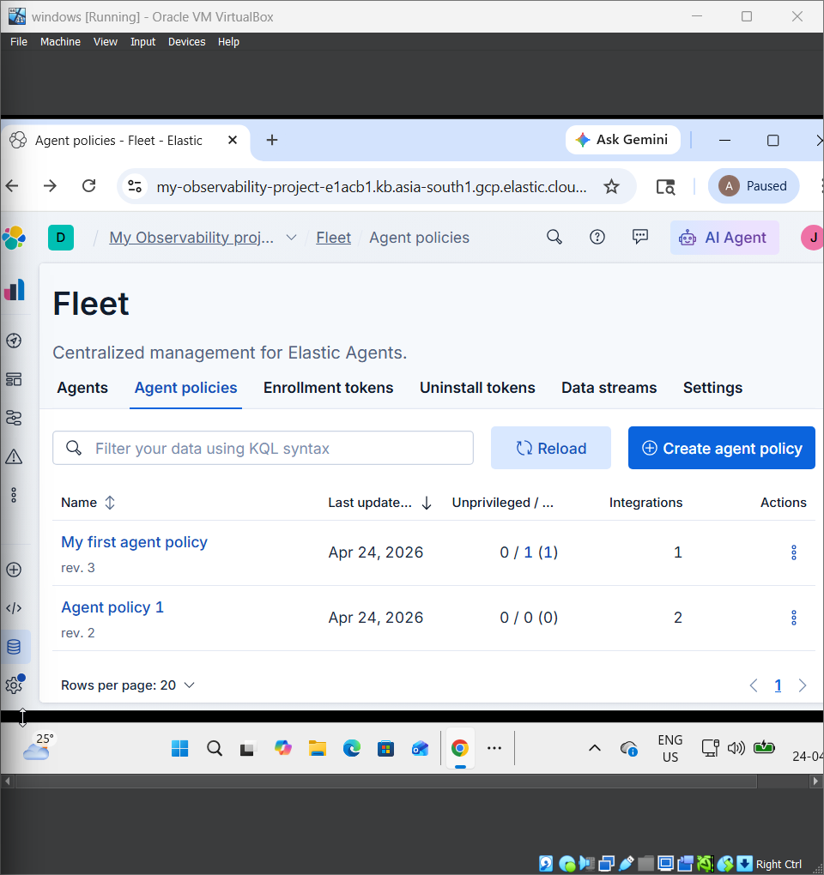



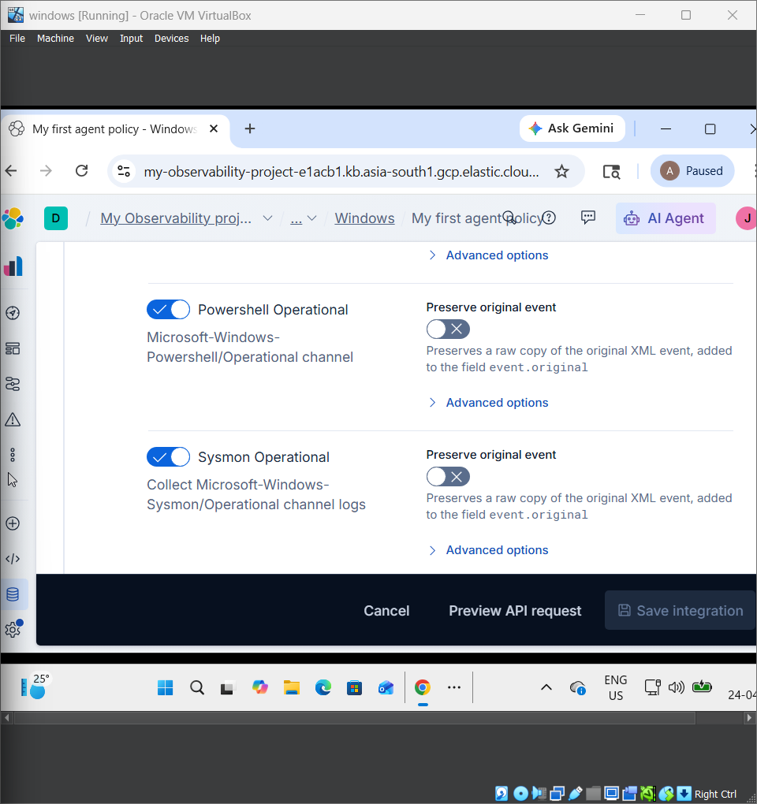

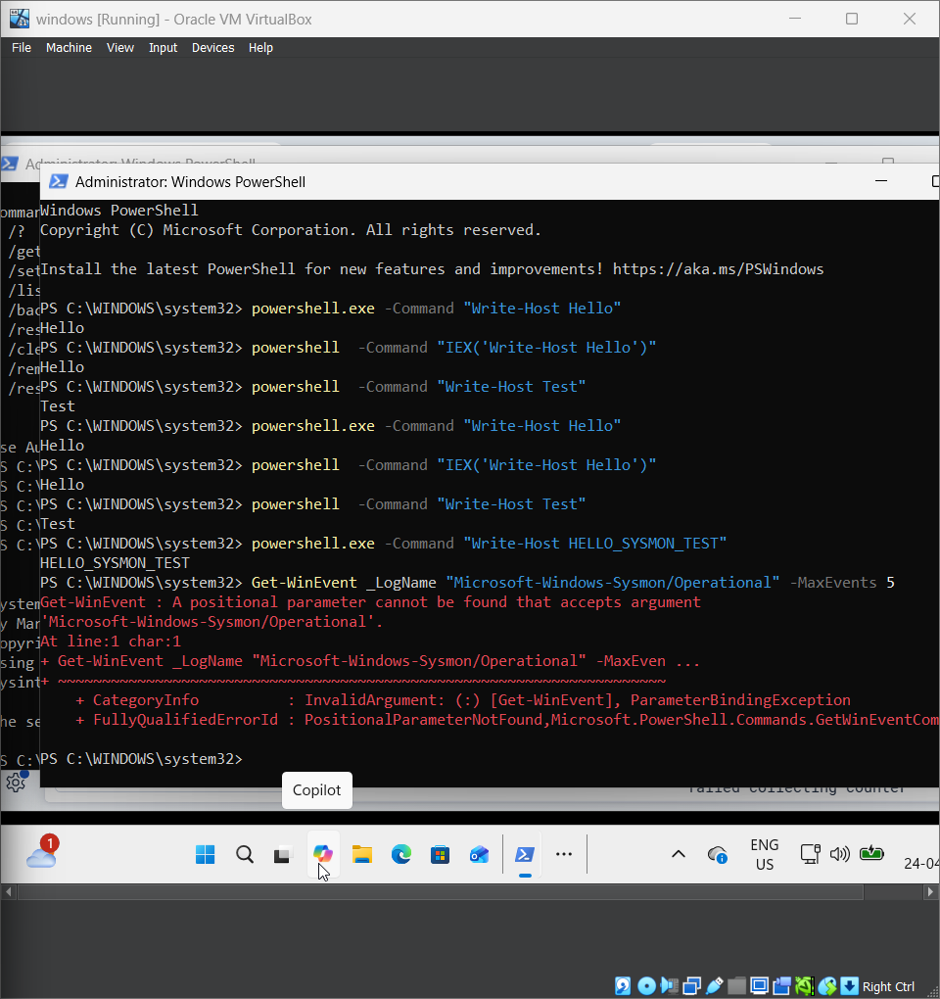

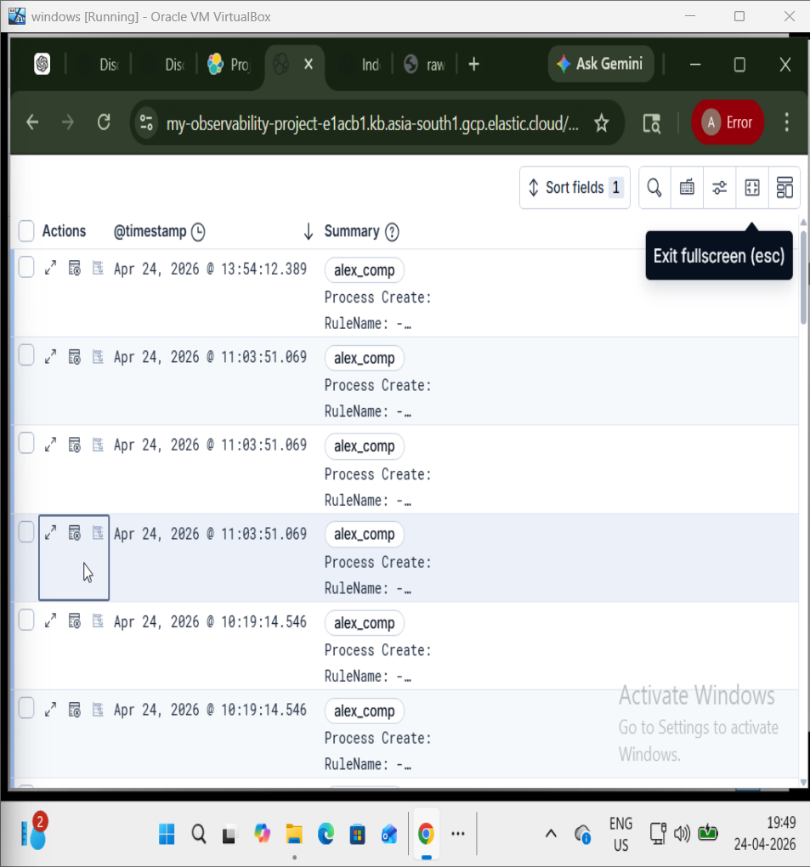

3.2 Sigma Rule Creation
A Sigma rule was created to detect PowerShell execution with command arguments.
title: Suspicious PowerShell Activity
logsource:
category: process_creation
product: windows
detection:
selection:
Image|endswith: '\powershell.exe'
CommandLine|contains: '-Command'
condition: selection

3.3 Testing
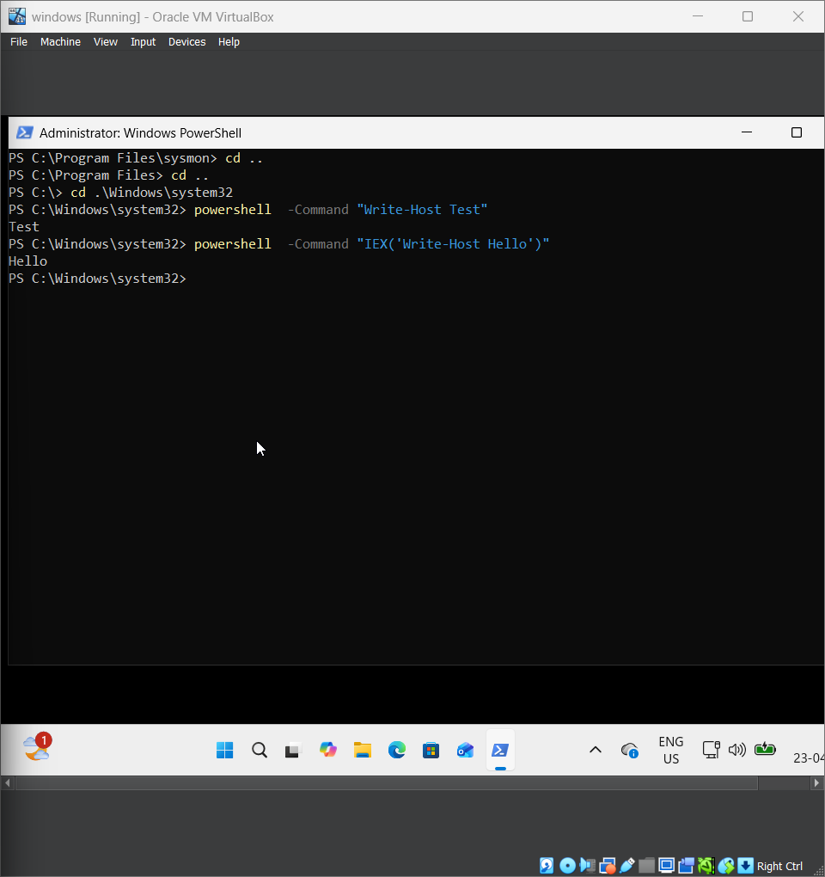
Tested using: powershell -Command "Write-Host Test"

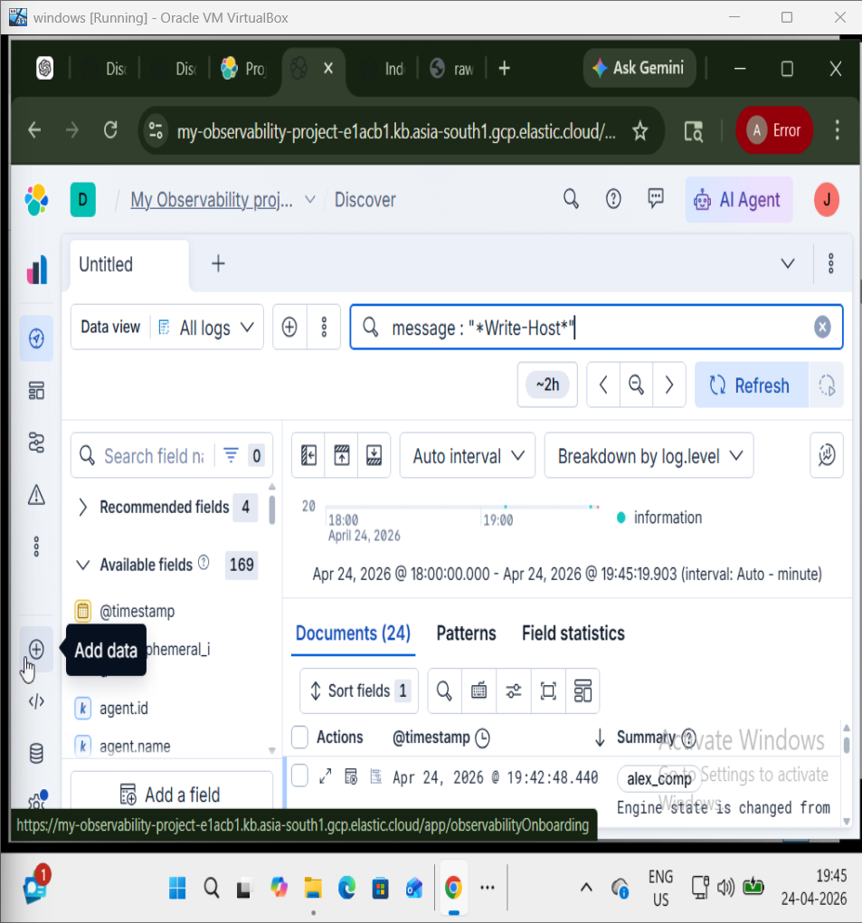

4. Threat Hunting Query
event.code: 4688 AND process.name: "powershell.exe"

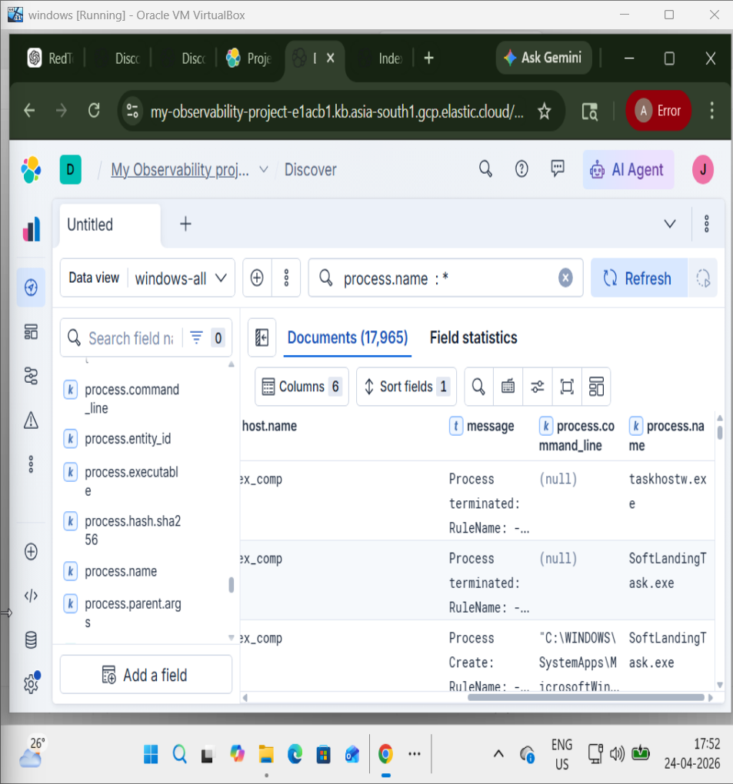

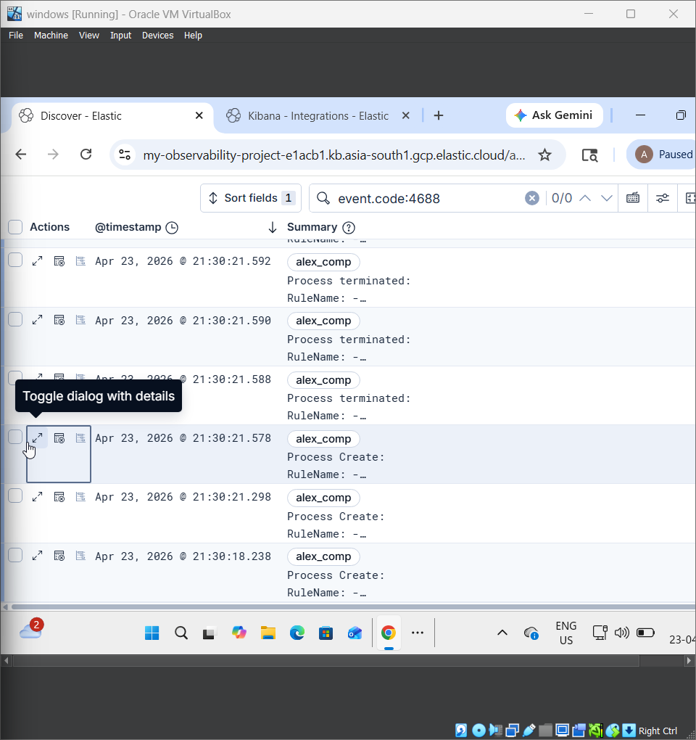

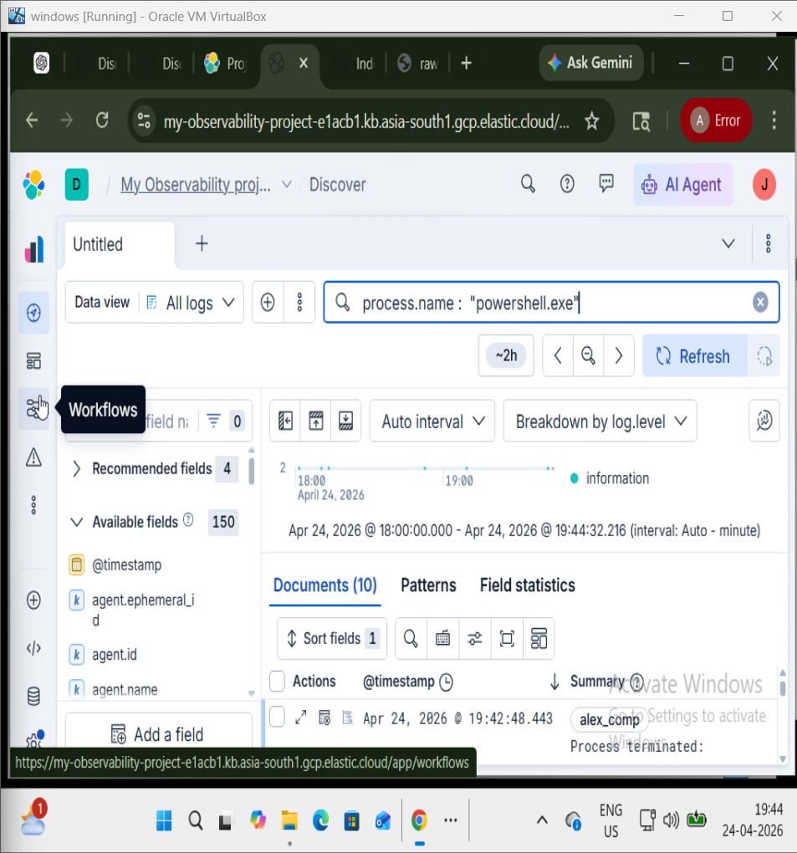

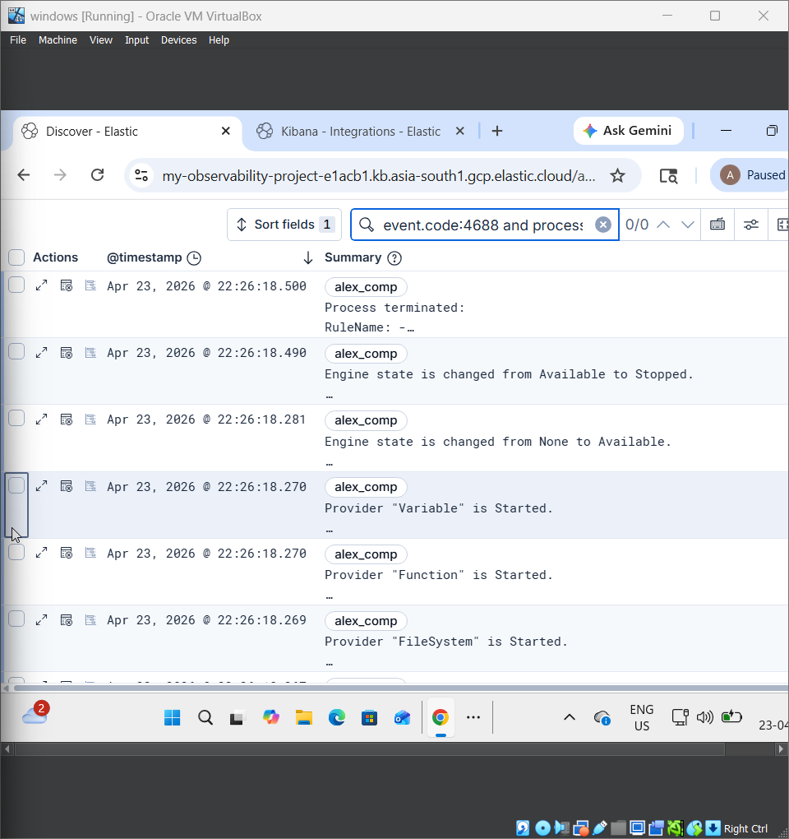

5. Findings

Timestamp | Process | Command Line | Notes
2025-08-18 10:00:00 | powershell.exe | -Command Write-Host Test | Suspicious execution
2025-08-18 10:05:12 | powershell.exe | -Command Get-Process | Likely admin activity
  2025-08-18 10:07:45 | powershell.exe | -Command Invoke-WebRequest | Potentially suspicious

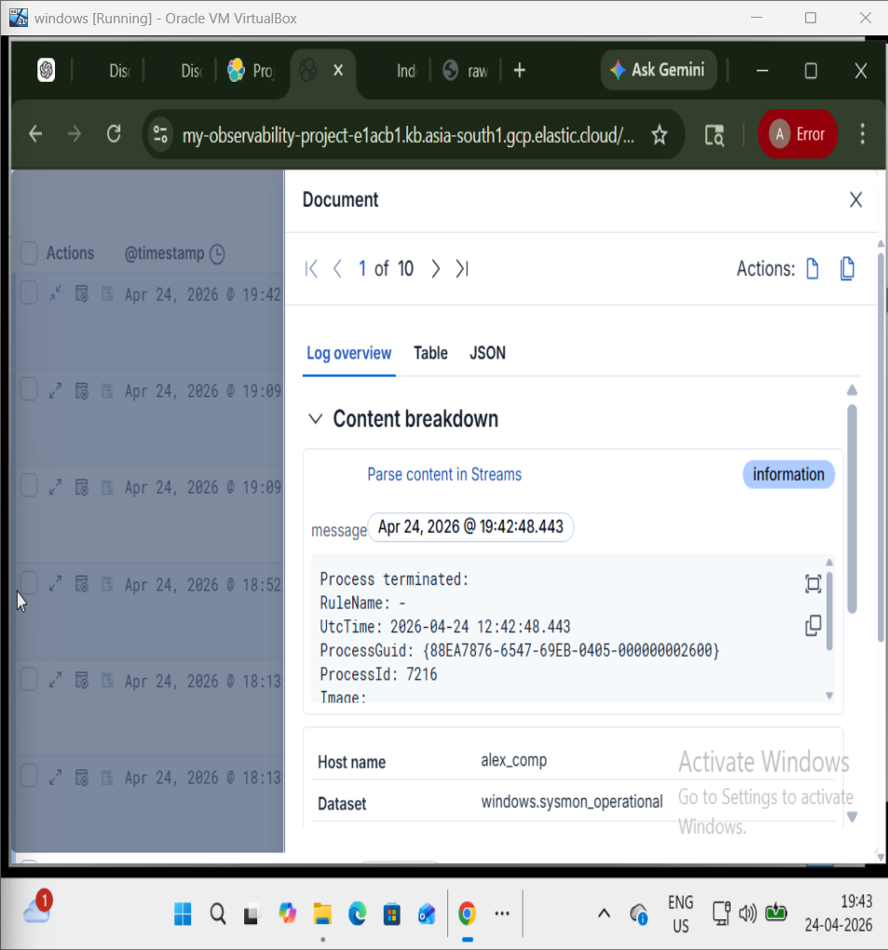

6. Analysis
PowerShell can be used for both legitimate and malicious purposes. The -Command flag indicates script execution.

7. Challenges
Distinguishing legitimate vs malicious activity and handling false positives.

8. Recommendations
Enhance rules with keywords, enable PowerShell logging, and correlate with network logs.

9. Conclusion
Open-source tools effectively detected suspicious PowerShell activity.

